Dermatomes and Cutaneous innervation of the Upper limbs, Lower limbs and trunk
Cutaneous nerves and dermatomes of the lower limb: anterior  - 1 12th thoracic  - 2 Femoral branch of genitofemoral  - 3 Ilioinguinal  - 4 Lateral cutaneous nerve of thigh  - 5 Obturator  - 6 Intermediate femoral cutaneous  - 7 Medial cutaneous nerve of thigh  - 8 Saphenous  - 9 Lateral cutaneous nerve  - of leg  - 10, 11Superficial peroneal  - 12 Sural  - 13 Deep peroneal  - L, Lumbar  - S, Sacral  - 8.84 Cutaneous nerves and dermatomes of the lower limb: anterior  - The numbers on the left limb, scrotum and perineum denote the nerve roots | 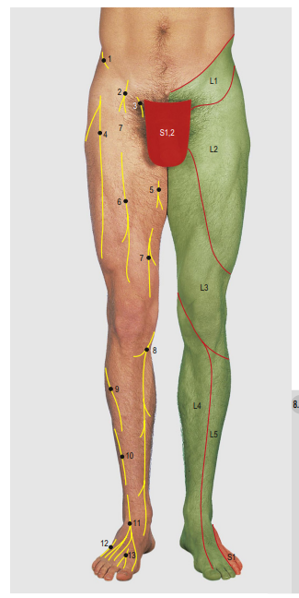
Cutaneous nerves and dermatomes of the lower limb: posterior  1 Lumbar  2 Sacral  3 Iliohypogastric  4 12th thoracic  5 Lateral cutaneous nerve  of thigh  6 Posterior cutaneous nerve  of thigh  7 Obturator  8 Medial cutaneous nerve of thigh  9 Lateral cutaneous nerve  of calf  10 Sural communicating  11 Sural  12 Saphenous  13 Tibial (medial calcaneal)  L, Lumbar  S, Sacral | 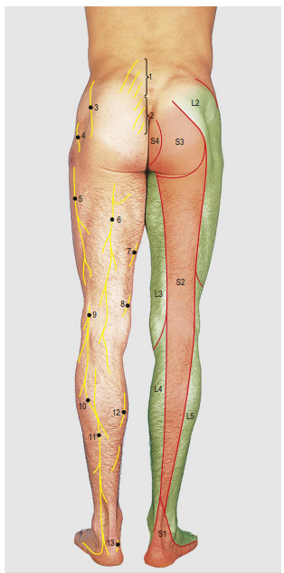
Cutaneous dermatomes  of the sole: lumbar fourth  and fifth and first sacral  nerve roots | 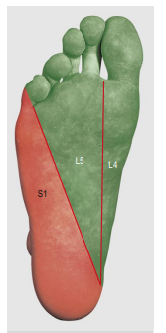
Cutaneous innervation  of the sole  - 1 Saphenous  - 2 Medial plantar  - 3 Lateral plantar  - 4 Sural  - 5 Tibial (medial calcaneal) | 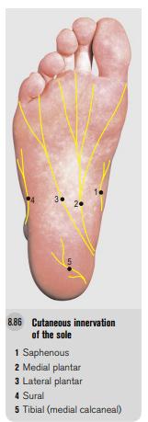
Cutaneous nerves and dermatomes of the upper limb: anterior | 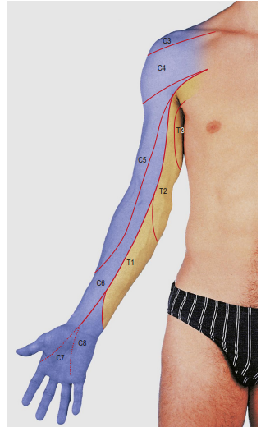
Cutaneous nerves of the upper limb: anterior  1 Supraclavicular  2 Upper lateral cutaneous nerve of arm  3 Intercostobrachial  4 Anterior cutaneous nerve of arm (branch of 5)  5 Medial cutaneous nerve of arm  6 Medial cutaneous nerve of forearm  7 Lateral cutaneous nerve  of forearm  8 Palmar branch of ulnar  9 Palmar branch of median  10 Superficial terminal branch of radial  11 Ulnar digital  12 Median digital | 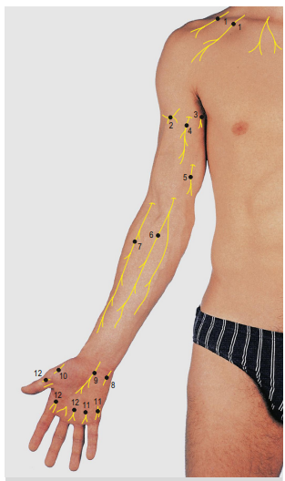
Dermatomes of the upper limb: Posterior | 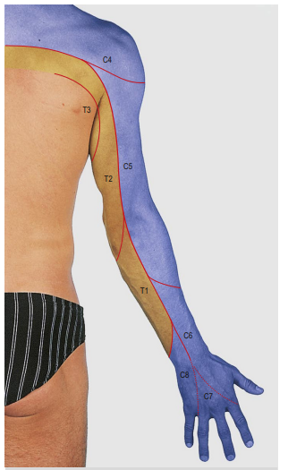
Cutaneous nerves of the upper limb: Posterior  1 Supraclavicular 2 Upper lateral cutaneous nerve of arm 3 Posterior cutaneous nerve of arm 4 Intercostobrachial 5 Lower lateral cutaneous nerve of arm 6 Medial cutaneous nerve of arm 7 Posterior cutaneous nerve of forearm 8 Lateral cutaneous nerve of forearm 9 Medial cutaneous nerve of forearm 10 Radial 11 Dorsal branch of ulnar | 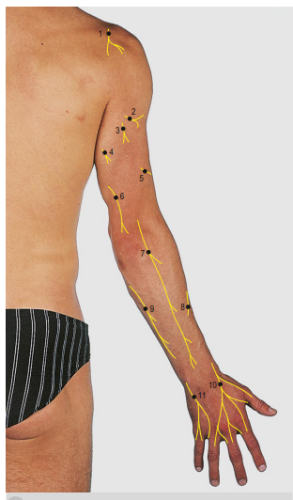
Dematomes of the anterior and posterior trunk

